1. APT Project Progress Summary
Below, you will find several fields that you must complete with the requested information.

APT Project Progress Summary | To date, the project has advanced mainly in its documentation and analysis phase, and has started the development stage.  In the documentation phase, the requirements of the clinical management system for the midwifery area of the maternal and child health program at a CESFAM were gathered through direct contact with practicing midwives. As a result, a table of 28 requirements (23 functional and 5 non-functional) and 16 use cases were defined, of which 11 correspond to maintenance modules and 6 to business processes. The project plan was also drawn up, including the WBS with the cost estimate, and the activity diagrams for the use cases are currently being modeled.  As for development, construction of the system with a layered architecture has begun. So far, work has been done on modules or features that have been started, for example: role-based authentication, maintenance modules, base project structure, database
Objectives | The objectives have not been adjusted
Methodology | The project will be approached through a classic incremental method, combining traditional phase structures for management and formal documentation (reflected in the Gantt Chart) with agile development practices for software construction—meaning a hybrid approach.
Evidence of progress | - Requirements Template o Requirements Sheet (Planilla de Requerimientos)  - Gantt Chart / Roadmap depending on the methodology (Carta Gantt/RoadMap dependiendo de la metodología)  - WBS - Costs [WBS = Work Breakdown Structure] (EDT - Costos)  - SRS Document [SRS = Software Requirements Specification] (Documento ERS)  - Extended Use Case Document (Documento Caso de uso extendido)  - Full System Mockups (Mockups del sistema completo)  - SAD Document [SAD = Software Architecture Document] (Documento Arquitectura - DAS)  - Business Process Document (TO-BE) (Documento proceso de negocio - TO-BE)  - RACI Matrix (Matriz RACI)  - Risk Matrix (Matriz de Riesgo)  - Data Dictionary (Diccionario de Datos)  - Change Control Matrix (Matriz Control de Cambios)  Evidence
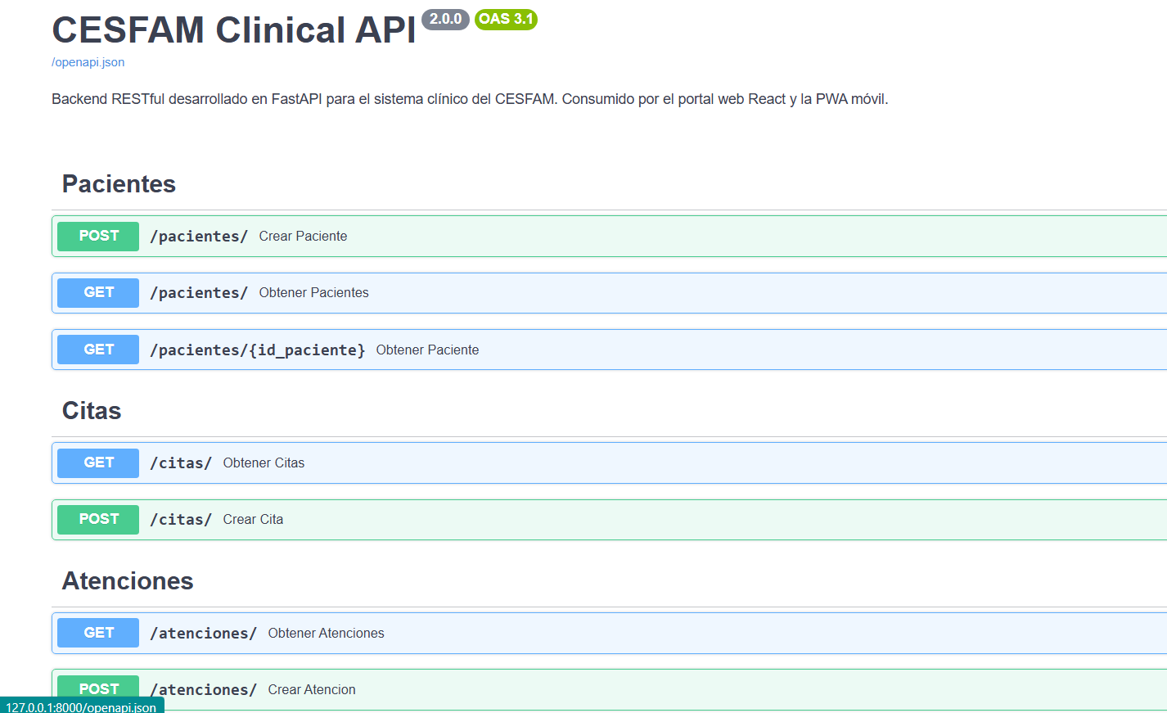
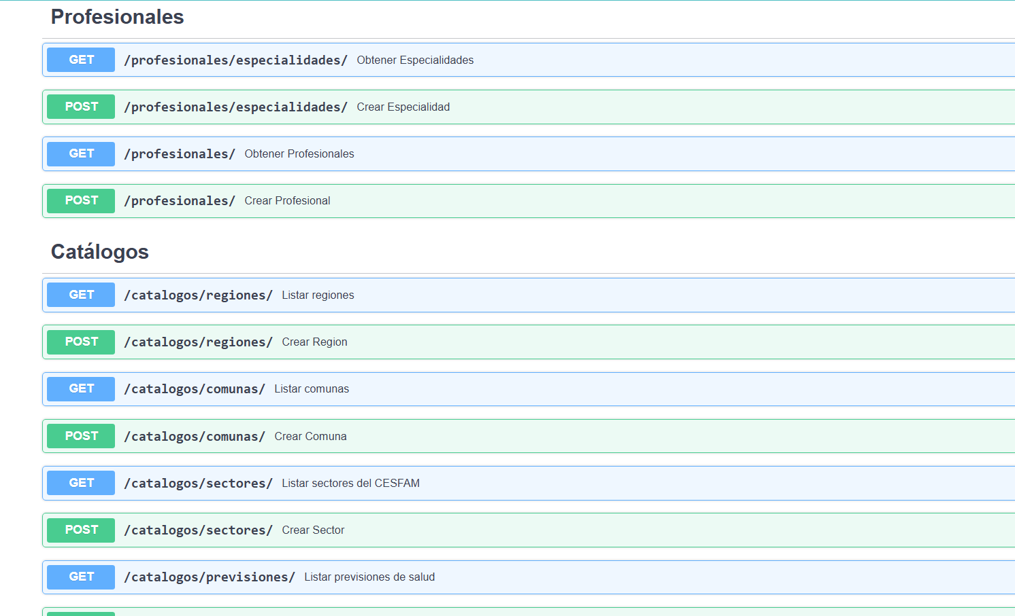
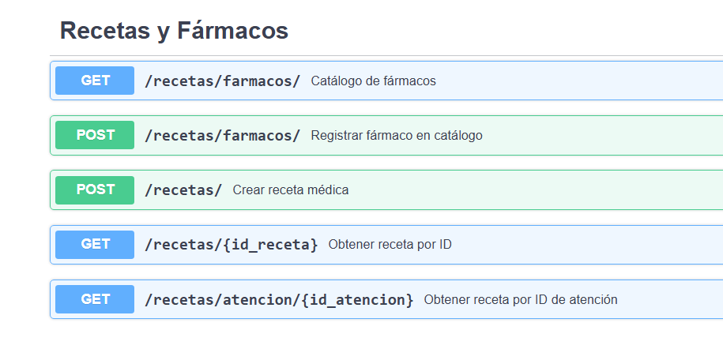
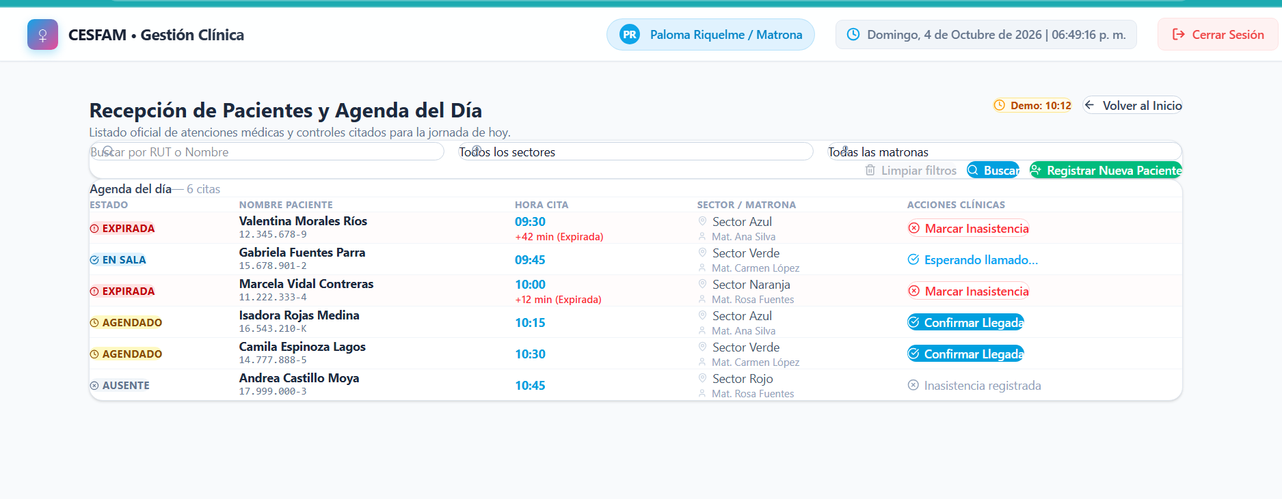
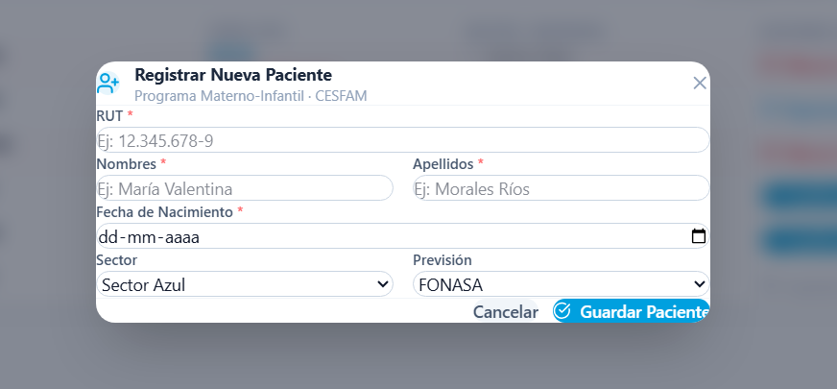

2. Work Plan Monitoring
Carefully review your work plan, paying special attention to the progress status and adjustments columns.

Work plan
Competency or competency units | Activities | Resources | Activity duration | Person in charge | Remarks | Progress status | Adjustment
Requirements analysis and gathering competency | Gathering requirements with practicing midwives | Meetings with midwives, documentation of the current workflow, Rayen as a reference | 2 Weeks | Diego Munoz | N/A | Completed | No adjustment
Software analysis and design competency | Definition of requirements and use cases | Project documentation, Word/Excel | 1 Week | Roberto Roman | N/A | Completed | No adjustment
Modeling competencies | Activity diagrams of the use cases | Modelio | 5 Days | Roberto Roman | Large number of diagrams that repeat | Completed | Requirements modification
Project management competency | Planning and cost estimation (WBS) | Excel | 1 Week | Diego munoz | N/A | Completed | No adjustment
Database competency | Design of database models | Data modeler, Sql Developer, Draw.io | 2 Weeks | Juan Pablo, diego munoz | N/A | Completed | No adjustment
Development competency | Application development | React, among others | 6 Weeks | Juan Pablo | N/A | In progress | No adjustment
Software quality competency | System testing | Postman, Excel, Selenium | 4 Weeks | Roberto Roman | An attempt will be made to automate one flow | Not started | No adjustment

3. Adjustments based on monitoring
Look more closely at the remarks in your work plan. Analyze the planned activities and point out which aspects facilitated or hindered the execution of the plan. Explain how you addressed and/or will address the obstacles. Finally, indicate the adjustments you made to the work plan based on this analysis.

Facilitating Factors:
- Efficient communication and teamwork: The clear division of roles based on competencies (Project Manager, Analyst/QA, DBA/Designer) has allowed tasks to be carried out in parallel without bottlenecks.
- Direct access to key users: The availability and constant interaction with practicing professional midwives made it possible to gather requirements accurately and in line with the reality of the CESFAM
- Use of clear standards and methodologies: The use of a hybrid methodology together with standardized modeling and estimation tools (WBS, IEEE 830) ensured a smooth workflow from the analysis phase.

Hindering Factors and Actions Taken:
- Action taken: A strategic restructuring was carried out to unify modules and consolidate related use cases (for example, unifying the recording of anamnesis and diagnosis within the Clinical Care Module). This optimized modeling time without cutting the scope of the software.

Adjusted or eliminated activities:
Adjusted or eliminated activities:
- Adjustment made: No activities were eliminated and the functional scope of the project was not reduced. The only technical adjustment applied was the restructuring and simplification of the requirements and use case matrix.
- Absence of other adjustments: No adjustments to deadlines or budget were required, because the schedule and the effort estimate in Man-Hours (WBS) have proven to be highly realistic and suited to the team's working capacity.

Activities that have not started or are delayed:
Activities that have not started or are delayed:
- Compliance status: There are no delayed activities to date. The Requirements Gathering, Analysis, Design, DB Modeling and WBS phases were 100% completed within the established deadlines. The Application Development phase is in progress according to the plan.
Strategies to Maintain Compliance:
- Continue with iterative, modular, layer-by-layer development.
- Run unit tests in parallel with backend development (using Postman) so that, when the official QA phase is reached, the system has a minimal failure rate and the flow can be automated without overtime.

